**AJAX and PARTIAL PAGE (Lesson 8)**

Ajax:

* .js / jquery for changing page.
* Json / xml to change the data.

For database updates use EF.

Able to use to perform partial updates as well

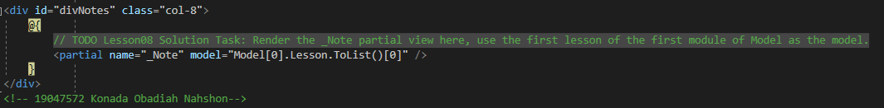

(Use of ASP for input ^)

**WEB API (Lesson 9)**

* WEB API with correct routing
* Processing the return

**WEB API (Lesson 10)**

* Use of Postman for verification
* Implementing actions according to requirements

